C:\Users\susanne\Desktop\sandsharks\SSS Gear Logos PR\Logos and pix\logo_usaswimming.gif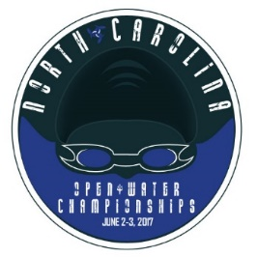NC OPEN WATER CHAMPS CLINIC

LED BY USA NATIONAL TEAM SWIMMERS

CHIP PETERSON AND ASHLEY TWICHELL

*June 3, 2017 Lake Echo, Seven Lakes*

* ***Following Saturday’s 800 M Race (approx. 5 pm-6 pm)***
* ***$20 early registration/$25 on site.***
* ***Everything you need to know to make your race the best!***

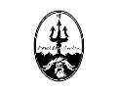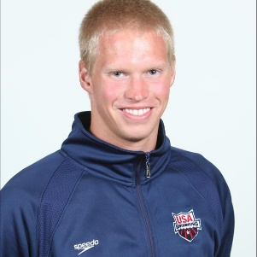

**SWIMMER STATS:  CHIP PETERSON**

DOB: DECEMBER 3, 1987

HOMETOWN: PINE KNOLL SHORES, N.C.

BIRTHPLACE: MOREHEAD CITY, N.C.

**CAREER HIGHLIGHTS**

Won the 2015 FINA 10-kilometer Marathon Swimming World Cup stop in Setubal, Portugal ... Finished second in the 5K at 2011 Open Water Nationals ... Gold medalist in the 10K open water race at the 2010 MOO Pan Pacific Championships … Placed 13th in the 10K at the 2008 Open Water World Championships in Seville, Spain ... Earned silver in the 10K at the 2007 Open Water World Championships Trials ... Captured 10K victories at the 2005, 2006 and 2007 Open Water National Championships, 2005 World Championships and at the 2006 Pan American Open Water Championships ... Took gold in the 1500m free and silver in the 10k Open Water event at the 2007 Pan American Games ... His victory at the 2005 World Champs made him the first American male since 1991 to capture an open water world title.

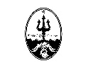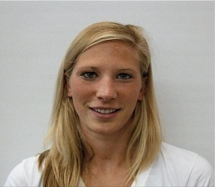

**SWIMMER STATS: ASHLEY TWICHELL**

DOB: JUNE 16, 1989

HOMETOWN: FAYETTEVILLE, N.Y.

**CAREER HIGHLIGHTS**

Silver medalist in the 800m free at the 2016 FINA World Championships (25m) ... Finalist in the 800m free at the 2016 U.S. Olympic Trials ... Champion in the 10K and was eighth in the 5K at 2016 Open Water Nationals ... Placed sixth in the 5K and ninth in the 25K at the 2015 FINA World Championships ... Took third in the 10K and second in the 5K at 2015 Open Water Nationals ... Won gold in the open

water 10K at the 2013 World University Games ... Swept the 5K and 10K titles at 2012 Open Water Nationals ... Won gold in the 5kKTeam Pursuit and bronze in the 5K at the 2011 FINA World Championships ... Finished third in the 800m free at the 2011 ConocoPhillips National Championships ... Won the 5K and placed third in the 10K at the 2011 USA Swimming Open Water National Championships.

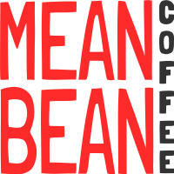An ***Open Water dinner*** at Filly and Colts (Little River Resort) will follow the Clinic. Register at [Sandshark.org.](https://www.teamunify.com/Home.jsp?_tabid_=0&team=ncssst)

